MINOR PROJECT

REPORT ON

ONLINE MEDICINE STORE

 ***JEEVANDEEP MAHAVIDYALAYA***

**Affiliated to M.G.K.V.P Varanasi**

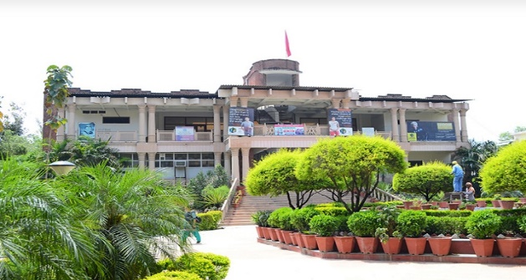

**SESSION – 2019-2022**

**SUBMITTED TO SUBMITTED BY**

**MR. RAJESH KUMAR SINGH KAUSHAL TRIPATHI**

**(LECTURER) BCA V SEM.**

**JDMV, VARANASI ROLL NO:-13220407076**



## JEEVANDEEP MAHAVIDYALAYA

## BAdALALPUr Varanasi

# *CERTIFICATE*

This is to certify that project report entitled on HTML ONLINE MEDICINE STORE

Submitted by KAUSHAL TRIPATHI in partial fulfilment of B.C.A (Bachelor Of

Computer Application) of University M.G.K.V.P Varanasi is a bona fide project work

carried out Under the supervision of Mr. RAJESH KUMAR SINGH (LECTURER)

for the Academic year 2021-2022.

In my opinion the report fulfils the requirements of standard work for JEEVANDEEP

MAHAVIDYALAYA, VARANASI.

Date………………………

Mr. Rajesh Kumar Singh Mr. Vikram Pratap Singh

(LECTURER) (HOD)

**PREFACE**

To develop good skills one should have vast practical exposure along with the theoretical knowledge. **ONLINE MEDICINE STORE** Project makes the student fully aware with the intricacies and usefulness of **ONLINE** **MEDICINE STORE** offers a real exposure of the various attributes associated with the practical knowledge of the project.

As a part of the academic syllabus of the three years **B.C.A**. we get the opportunity to do the **ONLINE MEDICINE ST**ORE This project is completely based on technology.

**Kaushal Tripathi**

**BCA Vth SEM.**

**Roll NO-13220407076**

# Declaration

I here by declare that the information presented in the Web Design project report entitled **ONLINE MEDICINE STORE** is correct to the best of my knowledge.

Date………………

**Kaushal Tripathi**

Place………………

**ACKNOWLEDGEMENT**

I express my sincere regard and indebtedness to my project external guide **Mr. Vikram Pratap Singh**, Jeevandeep Mahavidyalaya, Varanasi for his valuable time, guidance, encouragement, support and cooperation throughout the duration of our project.

I would sincerely like to thank BCA Department for giving me the opportunity to work on enhancing my technical skills while undergoing this project. This project was done under the guidance of **Mr. Rajesh Kumar Singh** BCA Department. This project helped in understanding the various parameters which are involved in the development of a web application and the working and integration of front end along with the back end to create a fully functional web application.

I would like to thank Professor **Mr. Vikram Pratap Singh (HOD)** BCA Department and whole of department for their constant support.

**Kaushal Tripathi**

**BCA Vth Sem.**

**Roll No. 13220407076**

**ABSTRACT**

Average Indians spend a significant amount of income on medicine. A reliable and fast online medicine delivery system is not ubiquitous. Most people buy medicine from the local Pharmacies. They need to go to medicine stores to buy the specific medicine prescribed by the specialized doctors. Sometimes all prescribed medicines are not available in local Pharmacies therefore people need to go to other areas to buy the medicines. It is very time consuming and people need to spend money as well for this. In our country, traffic jams are a very big problem. People waste longer time on the road due to traffic jams. Here most of the pharmacies are closed at night time but sometimes in an emergency situation medicine is very essential. In this case an online web based e-commerce medicine delivery system is needed very much. Online pharmacy is web based application. User can post requirement for medicine. User can purchase medicine online. Medicine delivery provided by the nearest associate store. Prescription is mandatory for ordering medicine. As per prescription user can search medicine and useful information. This application can provide information for daily consumption of medicine. This application provides pre- information of side effects and allergy of medicine. This application provides logins to the users. They can maintain their account.

# INTRODUCTION

An online medicine delivery system is an online based web application that operates over the Internet and sends orders to customers through credit cards, shipping companies, or pay on delivery system. People can buy and sell their products sitting at home. It is getting popular day by day all over the world even in domestic market space. The aim is to make the ordering process and delivery systems of medicines much easier and customer-friendly. It’s very important to make a user friendly environment.

The illustration goes as follows: firstly the user will visit the homepage and log in with his designated username and password. If anyone provides an invalid or incorrect username and password, the system will display an error message. For new customer the provider needs to give proper name and email address to register.

After registration is complete the user can purchase any item form the website. There is a search machine form which one can search for specific medicine. After selecting the desired item user can add them to cart and order the item. Then, deliver system will take place. The delivery boy will take the order to nearby store and deliver the item within a short time. The above figure of the flowchart illustrates the methodology in which our system conducts the processes.

The most important objective of online remedy ordering gadget is to automate the existing manual system with the assist of increase automated software so, that treasured statistics can be stored for longer period with clean having access to and manipulation of the identical. The registered user can get admission to the account with valid credentials. User can surf the drugs gadgets consistent with classes, Cart and online charge options are available to user.

User can tune their orders with the medicine info. In Online medicine Ordering

System Admin can deal with the functionalities like add new medicinal drug objects, edit/delete medication items, Enable/Disable the medicine objects in line with availability and their expiry dates. Admin have authority to view order details and update the transport popularity of medicines.

The client is a small scale pharmaceutical company that is distributing generic medicines to emergency medicines and having a good network of medical (retail) stores. Main need of the client is to prepare an online application to help the needy people in finding the availability of the medicine and a list of medical stores where the medicine is available. The visitor can quickly find the nearest medical store by selecting the area in the search tools.

This application also provides a login account to a registered medical store. Using this account a person from the medical store can update the list of medicines and their stock on daily-wise. This avoids providing outdated data to the visitor.

## 

**Frontend Development**: The part of a website that the user interacts directly is termed as front end. It is also referred to as the ‘client side’ of the application.

[**HTML:**](https://www.geeksforgeeks.org/html-tutorials/) HTML stands for HyperText Markup Language. It is used to design the front end portion of web pages using markup language. It acts as a skeleton for a website since it is used to make the structure of a website.

[**CSS**:](https://www.geeksforgeeks.org/css-tutorials/) Cascading Style Sheets fondly referred to as CSS is a simply designed language intended to simplify the process of making web pages presentable. It is used to style our website.

**SYSTEM ANALYSIS**

# EXISTING SYSTEM

An online medicine delivery system is an online based web application that operates over the Internet and sends orders to customers through credit cards, shipping companies, or pay on delivery system. People can buy and sell their products sitting at home. It is getting popular day by day all over the world even in domestic market space. The aim is to make the ordering process and delivery systems of medicines much easier and customer-friendly. It’s very important to make a user friendly environment. This section describes the basic structure of the proposed system.

## DRAWBACKS OF EXISTING SYSTEM

The direct attack effect such as service downtime, auto-scaling driven resource/economic losses, business and revenue losses, economic losses due to the downtime, and the service's downtime

# PROPOSED SYSTEM

User can tune their orders with the medicine info. In Online medicine Ordering System Admin can deal with the functionalities like add new medicinal drug objects, edit/delete medication items, Enable/Disable the medicine objects in line with availability and their expiry dates. Admin have authority to view order details and update the transport popularity of medicines. The fee transaction and consumer information are also viewable to admin.

## ADVANTAGES OF PROPOSED SYSTEM

Such as higher availability, cost reduction, efficient billing, reduced traffic congestion, fast system response, helpful services and effective management. For Medicine detection, mostly IR sensors, ultrasonic sensors, RFID tags and simple light sensors are used.

# FEASIBILITY STUDY

The feasibility Analysis is an analytical program through project manager determines the project success ratio and through feasibility study project manager able to see either project. The key considerations involved in the feasibility analysis are:

Economic Feasibility

Technical Feasibility

Operational Feasibility • Environmental Feasibility

## ECONOMICAL FEASIBILITY

Hence this project is economically feasible there is no need to involve any cost for this project.

## TECHNICAL FEASIBILITY

Software Technologies used are HTML and CSS. In the educational institutions, it is possible to update the system in future. No special hardware is required for the purpose of using this system. Hence it is declared that this project is technically feasible.

## OPERATIONAL FEASIBILITY

As the admin work mainly to maintain the User and Admin. User orders the medicine required and the Admin will checks , packs and delvers the required medicines to the respective users. Hence it is easy to operate with training. Therefore it is operationally feasible for implementation.

## ENVIRONMENTAL FEASIBILITY

An environmental feasibility study is a key part of the project initiation process and a critical factor in determining financial viability, risk potential and the sustainable future of the project.

Our teams, in collaboration with our winning Geographical Information Systems (GIS) technicians, deliver site feasibility studies and advice across a diverse range of industries, including: renewable energy, commercial and residential development, industrial and infrastructure projects. We have drawn on our vast experience to develop a staged approach to feasibility studies, which includes progressive levels of detail appropriate to the project stage. This is particularly beneficial to sites or projects which face potentially complex constraints.

Typically we would undertake three main phases in a site feasibility study, which can be tailored to fit with specific project approval gateway stages.

This project environment is correct as a admin has developed this system and no expenditure is involved under any head and this process is part of admin document management, this project environment is accessible.

**SYSTEM SPECIFICATION**

# HARDWARE REQUIREMENTS

The Hardware of the computer consists of physical component such as Input Devices, Storage Devices, Processing & Control units and Output Devices. Computer includes external storage unit to store data in programs.

The Hardware Configuration involved in this project

|  |  |
| --- | --- |
| • System | : core i3 |
| • Hard Disk | : 500 GB. |
| • Monitor | : 15 inch VGAColor. |
| • Mouse | : Logitech Mouse. |
| • Ram | : 4 GB |
| • Keyboard | : Standard Keyboard |
|  |  |

System of configurations similar to the above mentioned or above to the mentioned higher end can be used to run the code.

# SOFTWARE REQUIREMENTS

Software is a group of programs that computers need to do a particular task. It is an essential requirement of Computer System. The Software used to develop the project is

Operating System : Windows 10.

The Software like Windows 10 or Unix is sufficient to execute the codes.

## System Architecture

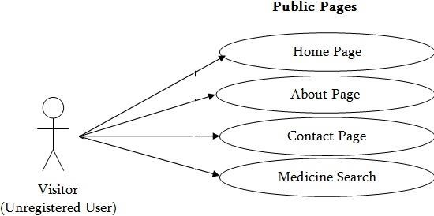

## Use Case Diagram

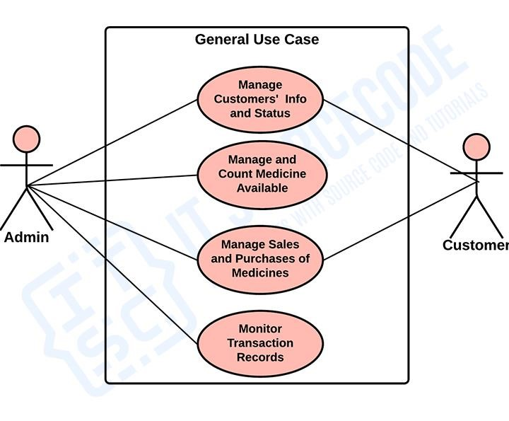



**SOFTWARE DESCRIPTION**

# FRONT END

* HTML
* Java Script

## HTML

The HyperText Markup Language, or HTML is the standard markup language for documents designed to be displayed in a web browser. It can be assisted by technologies such as Cascading Style Sheets (CSS) and scripting languages such as JavaScript.

Web browsers receive HTML documents from a web server or from local storage and render the documents into multimedia web pages. HTML describes the structure of a web page semantically and originally included cues for the appearance of the document.

HTML elements are the building blocks of HTML pages. With HTML constructs, images and other objects such as interactive forms may be embedded into the rendered page. HTML provides a means to create structured documents by denoting structural semantics for text such as headings, paragraphs, lists, links, quotes and other items. HTML elements are delineated by tags, written using angle brackets. Tags such as <img /> and <input /> directly introduce content into the page. Other tags such as <p> surround and provide information about document text and may include other tags as sub-elements. Browsers do not display the HTML tags, but use them to interpret the content of the page.

HTML can embed programs written in a scripting language such as JavaScript, which affects the behavior and content of web pages. Inclusion of CSS defines the look and layout of content. The World Wide Web Consortium (W3C), former maintainer of the HTML and current maintainer of the CSS standards, has encouraged the use of CSS over explicit presentational HTML since 1997.

## Architecture of HTML

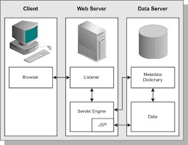

# HTML Architecture

## The Advantages of HTML

* HTML is widely used. 
* Every browser supports HTML Language. 
* Easy to learn and use. 
* HTML is light weighted and fast to load. 
* Do not get to purchase any extra software because it’s by default in every window. 
* Easy to use 
* Loose syntax (although, being too flexible won’t suit standards). 
* HTML is easy enough to write 
* HTML is that it is easy to code even for novice programmers. 
* HTML also allows the utilization of templates, which makes designing a webpage easy. 
* Very useful for beginners in the web designing field. 
* HTML can be supported to each and every browser, if not supported to all the browsers. 
* HTML is built on almost every website, if not all websites. 
* HTML is increasingly used for data storage as like XML syntax. 
* Free – You need not buy any software. 
* HTML is present in every window by default so you not need to buy the software which cost too much. 

# JAVA SCRIPT

## History

The JAVA language was created by James Gosling in June 1991 for use in a set top box project. The first public implementation was Java 1.0 in 1995. It promised

"Write Once, Run Anywhere” (WORA), providing no-cost runtimes on popular platforms. Java quickly became popular. With the advent of Java 2, new versions had multiple configurations built for different types of platforms. For Example J2EE was for enterprise applications and the greatly stripped down version J2ME was for mobile applications. J2SE was the designation for the Standard Edition. In 2006, for marketing purposes, new J2 versions were renamed Java EE, Java ME, and Java SE, respectively.

## The Java Programming Language

The Java programming language is a high-level language that can be characterized by all of the following buzzwords

* Simple 

* Architecture neutral 

* Object oriented 

* Portable 

* Distributed 

* High performance 

**What can we build using JavaScript ?**

JavaScript is a widely-used programming language. Given below are some domains/products that can be built using JavaScript:

Websites: JavaScript helps us to add behavior of our website. It helps users to interact with the website. For eg. clicking on buttons, saving details, uploading details on the website, etc.

Web Servers: We can make robust server applications using JavaScript. To be precise we use JavaScript frameworks like Node.js and Express.js to build these servers.

Game Development: In Game Development industry, JavaScript is used widely.

With the addition of HTML5 Canvas, it’s now possible to make 2D and 3D games in JavaScript very efficiently.

3D Drawings: JavaScript in addition with HTML Canvas is used to make threedimensional graphics.

Smartwatch Apps: The popular smartwatch maker Pebble has created Pebble.js, a small JavaScript framework that allows a developer to create an application for the Pebble line of watches in JavaScript.

**Why to learn JavaScript ?**

* No need of compilers: Since JavaScript is an interpreted language, therefore it does not need any compiler for compilations.
* Used both Client and Server-side: Earlier JavaScript was used to build clientside applications only, but with the evolution of its frameworks namely Node.js and Express.js, it is now widely used for building server-side applications too.
* Used everywhere: JavaScript is so loved because it can be used anywhere. It can be used to develop websites, games or mobile apps, etc.
* Huge community support: JavaScript has a huge community of users and mentors who love this language and take it’s legacy forward.

 

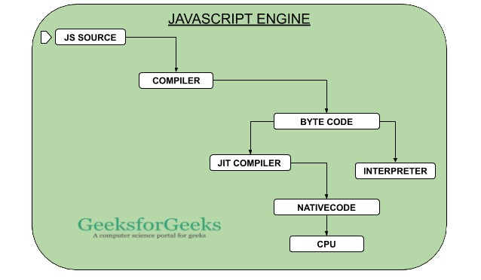The path of JavaScript

**Path of JavaScript**

# SYSTEM DESIGN AND DEVELOPMENT

# SYSTEM DESIGN

The design and development of the online medicine order service was based on the methodology for pharmaceutical care and Service Experiment Blueprint concepts, enabling the design of service characteristics and functionalities required by chronic patients . Service Experience Blueprint ensures a customer driven design able to co-create value with end customers . This method enhances the design of customer experiences, especially for technology-enabled services and contributes for a stronger focus on customer-firm relationship. Modeling methodologies can also provide an additional understanding of the dynamics of an organization to better align medical services’ design with operations .

A medicine delivery system is a solution designed specifically for users who want to order medicine products online and get them delivered to their home. A bit more details an online medicine delivery system is an online based web development that operates over the Internet and sends orders to customers through credit cards, shipping companies, or pay on delivery systems. People can buy and sell their products sitting at home . In this current pandemic situation of e-commerce businesses are becoming more popular. People have started to believe in online business to a great extent . In this pandemic the using and ordering from ecommerce site has become very famous. According to Statista, the size of the local e-commerce market was $ 1648 million.

**PROJECT DESCRIPTION AND MODULE DESCRIPTION**

* Strategy Phase

* Planning Phase

* Deployment Phase

## Strategy Phase

Customers typically by the hour, week or month, places the orders at

any instance. The server keeps on gatering the information, and based on the preference saves the order. This model does not require users to deploy in-house hardware and software.

### Planning Phase

It can be priced per application/user or gigabyte of memory consumed

per hour. The user approximation is done her and based on that the server planning is made.

**Deployment Phase**

Pricing can be based on features, storage capacity or on a per-user basis.

# 

# Source Code

**HOME PAGE HTML FILE**

<!DOCTYPE html>

<html>

<head>

<title>KT Medicare</title>

<link rel="stylesheet" type="text/css" href="css/style.css">

<link rel="stylesheet" href="https://cdnjs.cloudflare.com/ajax/libs/animate.css/3.7.2/animate.min.css">

</head>

<body>

<header>

<nav>

<div class="logo"><h1 class="animated infinite heartBeat">KT MEDICARE</h1></div>

<div class="menu">

<a href="#">Home</a>

<a href="aboutus.html">About</a>

<a href="product.html">Medicine</a>

<a href="contact.html">Contact</a>

</div>

</nav>

<main>

<section>

<h3><b>Welcome to Online Medicine Store</b></h3>

<h1>WE ARE HERE TO MAKE YOU FEEL BETTER<span class="change_content"> </span></h1>

<p><b>"In Need Of Medicines Think Of Us"</b></p>

<a href="aboutus.html" class="btnone">Learn more</a>

<a href="login.html"class="btntwo">Log-IN Here</a>

</section>

</main>

</header>

<footer>Copyright © 2021-2022 KT Medicare.

All Rights are reserved</footer>

</body>

</html>

***CSS FILE***

*\*{*

*margin: 0;padding: 0;box-sizing: border-box;*

*}*

*header{*

*width: 100%;height: 140vh;*

*background-image:linear-gradient(rgba(0,0,0,0.3),rgba(0,0,0,0.1)),url('../Image/image99.jpg');*

*background-repeat: no-repeat;*

*background-size: cover;*

*}*

*nav{*

*width: 100%;height: 15vh;*

*background: rgba(0,0,0,0.2);*

*color: skyblue;display: flex;justify-content: space-between;*

*align-items: center;text-transform: uppercase;*

*}*

*nav .logo{*

*width: 25%;text-align: center;*

*/*background: red;*/*

*}*

*nav .menu{*

*width: 40%;*

*display: flex;justify-content: space-around;*

*}*

*nav .menu a{*

*width: 25%;*

*text-decoration: none; color: white;*

*font-weight: bold;*

*}*

*nav .menu a:first-child{*

*color: #00b894;*

*}*

*main{*

*height: 100%;*

*width: 85vh;*

*display: flex;*

*justify-content: center;*

*align-items: center;*

*text-align: center;color: white;*

*}*

*section{*

*}*

*section h3{*

*font-size: 35px;font-weight: 200;letter-spacing: 3px;*

*text-shadow: 1px 1px 2px black;*

*}*

*section h1{*

*margin: 45px; 0 25px 0;*

*font-size: 55px;*

*font-weight: 700;*

*text-shadow: 2px 1px 5px black;*

*text-transform: uppercase;*

*}*

*section p{*

*font-size: 25px;*

*color: #eee;*

*white-space: 2px;*

*margin-bottom: 25px;*

*text-shadow: 1px 1px 1px black;*

*}*

*section a{*

*padding: 12px 30px;*

*border-radius: 4px;*

*outline: none;*

*text-transform: uppercase;*

*font-size: 13px;*

*font-weight: 500;*

*text-decoration: none;*

*letter-spacing: 1px;*

*transition: all .5s ease;*

*}*

*section .btnone{*

*/*background: #00b894;*/*

*background: #fff;*

*color: #000;*

*}*

*.btnone:hover{*

*background: #00b894;*

*color: white;*

*}*

*section .btntwo{*

*background: #00b894;*

*color: white;*

*}*

*footer{*

*text-align: center;*

*}*

*/*Designing of Contact Us*/*

*#ContactUs{*

*width:100vw;*

*height:100vh;*

*display:flex;*

*flex-direction: column;*

*align-items: center;*

*background-color: gray;*

*}*

*.form-shape input, .form-shape select, .form-shape textarea{*

*width: 92%;*

*padding: 0.5rem;*

*}*

*.btntwo:hover{*

*background: #fff;*

*color: #000;*

*}*

*.change_content:after{*

*content: '';*

*animation: changetext 10s infinite linear;*

*color: #00b894;*

*}*

*@keyframes changetext{*

*0%{content: "KT MEDICARE"}*

*20%{content: "HEALTHCARE FOR LIFE"}*

*35%{content: "OPEN 24h"}*

*60%{content: "BEST RATE"}*

*80%{content: "BEST MEDICINE"}*

*100%{content: "AT YOUR DOOR"}*

*}*

***LOG-IN HTML FILE***

*<!DOCTYPE html>*

*<html>*

*<head>*

*<meta charset="UTF-8">*

*<title>CodePen - Log-in</title>*

*<link rel='stylesheet' href='http://codepen.io/assets/libs/fullpage/jquery-ui.css'>*

*<link rel="stylesheet" href="css/stylelogin.css" media="screen" type="text/css" />*

*</head>*

*<body>*

*<form action="product.html">*

*<div class="login-card">*

*<h1>Log-in</h1><br>*

*<form>*

*<input type="text" name="user" placeholder="Username">*

*<input type="password" name="pass" placeholder="Password">*

*<input type="submit" name="login" class="login login-submit" value="login">*

*</form>*

*<div class="login-help">*

*<a href="#">Register</a> • <a href="#">Forgot Password</a>*

*</div>*

*</div>*

*<!-- <div id="error"><img src="https://dl.dropboxusercontent.com/u/23299152/Delete-icon.png" /> Your caps-lock is on.</div> -->*

*<script src='http://codepen.io/assets/libs/fullpage/jquery_and_jqueryui.js'></script>*

*</form>*

*</body>*

*</html>*

***LOG-IN CSS FILE***

*@import url(image/image98.webp);*

*body {*

*background: url(image/image98.webp) no-repeat center center fixed;*

*-webkit-background-size: cover;*

*-moz-background-size: cover;*

*-o-background-size: cover;*

*background-size: cover;*

*font-family: 'Roboto', sans-serif;*

*}*

*.login-card {*

*padding: 40px;*

*width: 274px;*

*background-color: #F7F7F7;*

*margin: 0 auto 10px;*

*border-radius: 2px;*

*box-shadow: 0px 2px 2px rgba(0, 0, 0, 0.3);*

*overflow: hidden;*

*}*

*.login-card h1 {*

*font-weight: 100;*

*text-align: center;*

*font-size: 2.3em;*

*}*

*.login-card input[type=submit] {*

*width: 100%;*

*display: block;*

*margin-bottom: 10px;*

*position: relative;*

*}*

*.login-card input[type=text], input[type=password] {*

*height: 44px;*

*font-size: 16px;*

*width: 100%;*

*margin-bottom: 10px;*

*-webkit-appearance: none;*

*background: #fff;*

*border: 1px solid #d9d9d9;*

*border-top: 1px solid #c0c0c0;*

*/* border-radius: 2px; */*

*padding: 0 8px;*

*box-sizing: border-box;*

*-moz-box-sizing: border-box;*

*}*

*.login-card input[type=text]:hover, input[type=password]:hover {*

*border: 1px solid #b9b9b9;*

*border-top: 1px solid #a0a0a0;*

*-moz-box-shadow: inset 0 1px 2px rgba(0,0,0,0.1);*

*-webkit-box-shadow: inset 0 1px 2px rgba(0,0,0,0.1);*

*box-shadow: inset 0 1px 2px rgba(0,0,0,0.1);*

*}*

*.login {*

*text-align: center;*

*font-size: 14px;*

*font-family: 'Arial', sans-serif;*

*font-weight: 700;*

*height: 36px;*

*padding: 0 8px;*

*/* border-radius: 3px; */*

*/* -webkit-user-select: none;*

*user-select: none; */*

*}*

*.login-submit {*

*/* border: 1px solid #3079ed; */*

*border: 0px;*

*color: #fff;*

*text-shadow: 0 1px rgba(0,0,0,0.1);*

*background-color: #4d90fe;*

*/* background-image: -webkit-gradient(linear, 0 0, 0 100%, from(#4d90fe), to(#4787ed)); */*

*}*

*.login-submit:hover {*

*/* border: 1px solid #2f5bb7; */*

*border: 0px;*

*text-shadow: 0 1px rgba(0,0,0,0.3);*

*background-color: #357ae8;*

*/* background-image: -webkit-gradient(linear, 0 0, 0 100%, from(#4d90fe), to(#357ae8)); */*

*}*

*.login-card a {*

*text-decoration: none;*

*color: #666;*

*font-weight: 400;*

*text-align: center;*

*display: inline-block;*

*opacity: 0.6;*

*transition: opacity ease 0.5s;*

*}*

*.login-card a:hover {*

*opacity: 1;*

*}*

*.login-help {*

*width: 100%;*

*text-align: center;*

*font-size: 12px;*

*}*

***ABOUT HTML FILE***

*<!DOCTYPE html>*

*<html>*

*<head>*

*<title style="color:blanchedalmond;">About us</title>*

*</head>*

*<style>*

*\* {box-sizing: border-box;}*

*body {*

*background-color: orange;*

*font-family: 'Playfair Display', serif;*

*}*

*/* Slideshow container */*

*.slideshow-container {*

*max-width: 1000px;*

*position: relative;*

*margin: auto;*

*}*

*/* Caption text */*

*.text {*

*color: #f2f2f2;*

*font-size: 15px;*

*padding: 8px 12px;*

*position: absolute;*

*bottom: 8px;*

*width: 100%;*

*text-align: center;*

*}*

*/* Number text (1/3 etc) */*

*.numbertext {*

*color: #f2f2f2;*

*font-size: 12px;*

*padding: 8px 12px;*

*position: absolute;*

*top: 0;*

*}*

*/* The dots/bullets/indicators */*

*.dot {*

*height: 15px;*

*width: 15px;*

*margin: 0 2px;*

*background-color: #bbb;*

*border-radius: 100%;*

*display: inline-block;*

*transition: background-color 0.6s ease;*

*}*

*.active {*

*background-color: #717171;*

*}*

*/* Fading animation */*

*.fade {*

*-webkit-animation-name: fade;*

*-webkit-animation-duration: 1.5s;*

*animation-name: fade;*

*animation-duration: 1.5s;*

*}*

*@-webkit-keyframes fade {*

*from {opacity: .4}*

*to {opacity: 1}*

*}*

*@keyframes fade {*

*from {opacity: .4}*

*to {opacity: 1}*

*}*

*/* On smaller screens, decrease text size */*

*@media only screen and (max-width: 300px) {*

*.text {font-size: 40px}*

*}*

*</style>*

*<body>*

*<div style="background-color:yellow;color":black;padding:10px><b>--About us--</b> </div>*

*<p style="color:white;">KT Medicare aims to deliver high quality medicies to all the customers at the right time for saving their valuable life.We offer premium and the largest range of original health and fitness products across various categories and leading brands. We dedicate this portal to all those people who are keen to purchase healthcare products online.*

*The aim is to supply cheaper products to everybody who has access to the internet and deliver those products to their door. Through harnessing the power of the internet and supplying you directly, this website will save up to 75% off the cost of many well known products found in your local Medical Shop.*

*We aim at covering various healthcare categories comprehensively which include –Diabetes,Nutrition,Sports and fitness,Body Building, Beauty care and Personel Care Produts,Mother and Baby Care and Health Devices. We enjoy comprehensive understanding of the shopper’s needs and make our best efforts to cater them with an extensive choice of both Indian and globalbrands*

*Offering a superior buying experience, we endow our esteemed customers with the best prices in market. we strive to achieve the highest level of customer satisfaction. Equipped with a well-informed team, using state of the art E-commerce platform, and prompt customer support system, we aim to offer our customers with unparalleled services.*

*We proudly manage our own warehousing operations that facilitate us to meet the daily orders of our customers and attain fastest shipping. We believe in adding new selections for our customers and making things easier to compare, find and discover varied products via our services.*

*online medical store offers a variety of key services includingayurvedic herbal pharmacy and over-the-counter medicines, vitamins and health supplements, family planning , ayurvedic herbal beauty cosmetic products, ayurvedic herbal medicine ,toiletries, electrical items and baby care products.*

*The service is supervised by fully qualified pharmacists who are available to discuss symptoms and issues about medical problems in a confidential environment through email and oversee all medicinal purchases.*

*So, make a move and Happy Shopping !!!! <br>*

*<br>*

*We're working to turn our passion for product into a booming online store. We hope you enjoy our products as much as we enjoy offering them to you.<br><br>*

*Sincerely,<br>*

*<b>Team KT Medicare</b></p><h2 style="color:red;text-align:center"><i>-- Stay home.. stay safe 😉😇--</i></h2>*

*<p style="color:orange"><b>Live Long Live Healthy!</b></p>*

*<a href="./product.html" class="button"><b>Let's Shop</b></a>*

*<div class="slideshow-container">*

*<div class="mySlides fade">*

*<div class="numbertext">1 / 3</div>*

*<img src="image\medicine-1.jpg" style="width:50%">*

*<div class="text"></div>*

*</div>*

*<div class="mySlides fade">*

*<div class="numbertext">2 / 3</div>*

*<img src="image\medicine-2.jpg" style="width:50%">*

*<div class="text"></div>*

*</div>*

*<div class="mySlides fade">*

*<div class="numbertext">3 / 3</div>*

*<img src="image\medicine-3.jpeg" style="width:50%">*

*<div class="text"></div>*

*</div>*

*</div>*

*<br>*

*<div style="text-align:center">*

*<span class="dot"></span>*

*<span class="dot"></span>*

*<span class="dot"></span>*

*</div>*

*<script>*

*var slideIndex = 0;*

*showSlides();*

*function showSlides() {*

*var i;*

*var slides = document.getElementsByClassName("mySlides");*

*var dots = document.getElementsByClassName("dot");*

*for (i = 0; i < slides.length; i++) {*

*slides[i].style.display = "none";*

*}*

*slideIndex++;*

*if (slideIndex > slides.length) {slideIndex = 1}*

*for (i = 0; i < dots.length; i++) {*

*dots[i].className = dots[i].className.replace(" active", "");*

*}*

*slides[slideIndex-1].style.display = "block";*

*dots[slideIndex-1].className += " active";*

*setTimeout(showSlides, 2000); // Change image every 2 seconds*

*}*

*</script>*

*</body>*

*</html>*

***CONTACT HTML FILE***

*<!DOCTYPE html>*

*<html lang="en">*

*<head>*

*<meta charset="UTF-8">*

*<meta name="viewport" content=*

*"width=device-width, initial-scale=1.0">*

*<link rel="stylesheet" href=".css">*

*<title>ContactUs</title>*

*<style type="text/css">*

*body {*

*color: black;*

*background-color:skyblue; }*

*img {*

*border: 0px solid #555;*

*}*

*</style>*

*</head>*

*<body>*

*<div id="ContactUs">*

*<h1>Contact Us</h1>*

*<form name="contact_details.html" method="post" action= "index.html">*

*<div class="form-shape">*

*<label for="query">*

*Type of Query*

*<select name="myQuery" id="query">*

*</label>*

*<option value="none" selected>*

*Select*

*</option>*

*<option value="order">*

*Order related Issues*

*</option>*

*<option value="Site">*

*Site related Issues*

*</option>*

*<option value="complaint">*

*Complaint related Issues*

*</option>*

*<option value="others">*

*Others*

*</option>*

*</select>*

*</div>*

*<div class="form-shape">*

*<label for="name">Name</label>*

*<input type="text" name="myName"*

*id="name"*

*placeholder="Enter your Name">*

*</div>*

*<div class="form-shape">*

*<label for="email">Email-Id</label>*

*<input type="email" name="myEmail"*

*id="email"*

*placeholder="Enter your email">*

*</div>*

*<div class="form-shape">*

*<label for="pho">Phone Number</label>*

*<input type="phone" name="myPhone"*

*id="pho"*

*placeholder="Enter your Phone no">*

*</div>*

*<div id="radio">*

*Are you a member of KT Medi Ordering System:*

*Yes <input type="radio" name="member" value="yes">*

*No <input type="radio" name="member" value="no">*

*</div>*

*<div class="form-shape"><br>*

*<label for="message">*

*Ellaborate your query*

*</label>*

*<textarea name="mesg" id="message"*

*cols="30" rows="10">*

*</textarea>*

*</div>*

*<input type="submit" value="Submit">*

*<input type="Reset" value="Reset">*

*</form>*

*<script>*

*function ordered(){*

*alert("your order has been placed");*

*}*

*</script>*

*</div>*

*</body>*

*</html>*

***MEDICINE HTML FILE***

*<!DOCTYPE html>*

*<html lang="en">*

*<head>*

*<meta charset="UTF-8">*

*<meta name="viewport" content="width=device-width, initial-scale=1.0">*

*<link rel="stylesheet" href="style.css">*

*<title>Products</title>*

*<style>*

*body{*

*background-color: orange;*

*font-family: 'Playfair Display', serif;*

*}*

*#our{*

*text-align: center;*

*font-size: 50px;*

*color: black;*

*}*

*.navbar-brand {*

*color: mediumslateblue;*

*font-size: 30px;*

*font-family: Georgia, 'Times New Roman', Times, serif;*

*letter-spacing: 2px;*

*position: absolute;*

*top: 20px;*

*left: 50px;*

*}*

*#info{*

*display: grid;*

*grid-template-columns: repeat(auto-fit,minmax(300px,1fr));*

*grid-column-gap: 10px;*

*grid-row-gap: 10px;*

*}*

*#info img{*

*width: 100%;*

*}*

*#info img:hover{*

*border-top-left-radius: 50px;*

*}*

*.img{*

*box-sizing: border-box;*

*box-shadow: 12px 10px 12px rgba(0, 0, 0, 0.5);*

*}*

*.img:hover{*

*box-shadow: none;*

*background-color: #fff;*

*border-bottom-right-radius: 50px;*

*border-top-left-radius: 50px;*

*}*

*button{*

*padding: 10px;*

*background: rgba(0, 0, 0, 0.5);*

*color: #fff;*

*border: none;*

*box-shadow: 12px 10px 12px rgba(0, 0, 0, 0.5);*

*}*

*@media (max-width: 710px){*

*.navbar-brand {*

*font-size: 15px;*

*top:20px;*

*left:15px;*

*}*

*}*

*</style>*

*</head>*

*<body>*

*<p class="navbar-brand" href="#">KT Medicare</p><br><br>*

*<h1 id="our">price list</h1>*

*<div id="info">*

*<div class="img">*

*<img src="image/image1.webp">*

*<div class="img-desc">*

*<h4><b>Name:</b> Paracetamol - 250 mg</h4>*

*<p><b>Price:</b> Rs. ₹25 per 10 tablets</p>*

*<p>For the treatment of mild to moderate pain, including headache, migraine, neuralgia, toothache, sore throat, period pains, aches and pains.</p>*

*<a class="btn" href="Medicine Order.html"><i class="fa fa-eye"></i> <button>Order Now</button></a>*

*</div>*

*</div>*

*<div class="img">*

*<img src="image/image2.jpg">*

*<div class="img-desc">*

*<h4><b>Name:</b> Paracetamol - 500 mg</h4>*

*<p><b>Price:</b> ₹50 per 10 tablets</p>*

*<p> It is used to treat headaches, migraine, nerve pain, toothache, sore throat, period (menstrual) pains, arthritis, muscle aches, and the common cold.</p>*

*<a class="btn" href="Medicine Order.html"><i class="fa fa-eye"></i> <button>Order Now</button></a>*

*</div>*

*</div>*

*<div class="img">*

*<img src="image\image3.jpg">*

*<div class="img-desc">*

*<h4><b>Name:</b>Dolo - 650 mg</h4>*

*<p><b>Price:</b> ₹75 per 10 tablets</p>*

*<p>Tablet helps relieve pain and fever by blocking the release of certain chemical messengers responsible for fever and pain.</p>*

*<a class="btn" href="Medicine Order.html"><i class="fa fa-eye"></i> <button>Order Now</button></a>*

*</div>*

*</div>*

*<div class="img">*

*<img src="image\image4.jpg">*

*<div class="img-desc">*

*<h4><b>Name:</b> Zofran</h4>*

*<p><b>Price:</b> ₹30 per 10 tablets</p>*

*<p> It is used to prevent and treat nausea and vomiting after surgery. It works by blocking one of the body's natural substances (serotonin) that causes vomiting.</p>*

*<a class="btn" href="Medicine Order.html"><i class="fa fa-eye"></i><button>Order Now</button></a>*

*</div>*

*</div>*

*<div class="img">*

*<img src="image\image5.jpg">*

*<div class="img-desc">*

*<h4><b>Name:</b> Attivan</h4>*

*<p><b>Price:</b> ₹60 per 10 tablets</p>*

*<p> It is approved for the treatment of anxiety, insomnia, or sleep difficulty due to anxiety or stress, status epilepticus (continuous seizures).</p>*

*<a class="btn" href="Medicine Order.html"><i class="fa fa-eye"></i><button>Order Now</button></a>*

*</div>*

*</div>*

*<div class="img">*

*<img src="image\image6.jpg">*

*<div class="img-desc">*

*<h4><b>Name:</b> Haldol</h4>*

*<p><b>Price:</b> ₹80 per 10 tablets</p>*

*<p>Haloperidol is a medication that works in the brain to treat schizophrenia. It is also known as a first generation antipsychotic (FGA) or typical antipsychotic.</p>*

*<a class="btn" href="Medicine Order.html"><i class="fa fa-eye"></i><button>Order Now</button></a>*

*</div>*

*</div>*

*<div class="img">*

*<img src="image\image7.jpg">*

*<div class="img-desc">*

*<h4><b>Name:</b> Digene</h4>*

*<p><b>Price:</b>₹240 per 1 tonic</p>*

*<p>Digene used to treat acidity, heartburn, indigestion, gastritis (inflammation of the stomach), and stomach upset.</p>*

*<a class="btn" href="Medicine Order.html"><i class="fa fa-eye"></i><button>Order Now</button></a>*

*</div>*

*</div>*

*<!-- start item 8 -->*

*<div class="img">*

*<img src="image\image8.jpg">*

*<div class="img-desc">*

*<h4><b>Name:</b> Asicot-o</h4>*

*<p><b>Price:</b> ₹90 per 1 tonic</p>*

*<p> This medication is used to treat and prevent ulcers in the intestines. Sucralfate forms a coating over ulcers, protecting the area from further injury. This helps ulcers heal more quickly.</p>*

*<a class="btn" href="Medicine Order.html"><i class="fa fa-eye"></i><button>Order Now</button></a>*

*</div>*

*</div>*

*<div class="img">*

*<img src="image\image9.jpg">*

*<div class="img-desc">*

*<h4><b>Name:</b>Pepcid</h4>*

*<p><b>Price:</b> ₹120 per 1 tonic</p>*

*<p>It is used to prevent and treat heartburn and other symptoms caused by too much acid in the stomach</p>*

*<a class="btn" href="Medicine Order.html"><i class="fa fa-eye"></i><button>Order Now</button></a>*

*</div>*

*</div>*

*<div class="img">*

*<img src="image\image01.jpg">*

*<div class="img-desc">*

*<h4><b>Name:</b> Digital Thermometer</h4>*

*<p><b>Price:</b> ₹500 per 1 item</p>*

*<p>Digital thermometers are temperature-sensing instruments that are easily portable, have permanent probes, and a convenient digital display</p>*

*<a class="btn" href="Medicine Order.html"><i class="fa fa-eye"></i><button>Order Now</button></a>*

*</div>*

*</div>*

*<div class="img">*

*<img src="image\image02.jpg">*

*<div class="img-desc">*

*<h4><b>Name:</b> Pulse Oximeter</h4>*

*<p><b>Price:</b>₹1200per 1 item</p>*

*<p>The pulse oximeter, or Pulse Ox, is an electronic device that measures the saturation of oxygen carried in your red blood cells.</p>*

*<a class="btn" href="Medicine Order.html"><i class="fa fa-eye"></i><button>Order Now</button></a>*

*</div>*

*</div>*

*<div class="img">*

*<img src="image\image03.jpg">*

*<div class="img-desc">*

*<h4><b>Name:</b> Diabetic Analyser</h4>*

*<p><b>Price:</b> ₹1400 per 1 item</p>*

*<p> Helps you to keep track of your blood glucose levels at different times of day such as Breakfast,Lunch and Dinner</p>*

*<a class="btn" href="Medicine Order.html"><i class="fa fa-eye"></i><button>Order Now</button></a>*

*</div>*

*</div>*

*</div>*

*</body>*

*</html>*

***MEDICINE ORDER HTML FILE***

*<!DOCTYPE html>*

*<html>*

*<head>*

*<meta charset="UTF-8" />*

*<title>HTML FORM</title>*

*<link rel="stylesheet" type="text/css" href="css/reset.css" />*

*<link rel="stylesheet" type="text/css" href="css/mycss.css" />*

*<style type="text/css">*

*body {*

*color: black;*

*background-color:skyblue; }*

*img {*

*border: 0px solid #555;*

*}*

*</style>*

*</head>*

*<body>*

*<script type="text/javascript">*

*function alertUser(msg) {*

*alert(msg);*

*}*

*</script>*

*</head>*

*<body onload="alertUser('Hello welcome!')">*

*<div style="text-align:center;padding:10px;">*

*<h1 style="color:indianred;">Welcome to our site</h1>*

*</div>*

*<h3>MEDICINE ORDER</h3>*

*<p><i>This Online Medicine ordering system lead to the efficiency of medicine businesses can be increased and the amount of time and effort spent can be reduced in dealing with medicine deliveries at home. This system is designed on elderly, person with disability, lactating mother and chronically ill patients that are not able to go in the pharmacy.They will just have an access through online delivery of medicine.An online pharmacy, internet pharmacy, or mail-order pharmacy is a pharmacy that operates over the Internet and sends orders to customers through mail, shipping companies, or online pharmacy web portal.</i></p>*

*<BR/>*

*<BR/>*

*<BR/>*

*<fieldset>*

*<center>*

*<div class="slideshow-container">*

*<div class="mySlides fade">*

*<div class="numbertext"></div>*

*<img src="image\kaushal1.jpg" style="width:20%" style="height: 50%;">*

*<div class="text"></div>*

*</div>*

*<br>*

*<div style="text-align:center">*

*<span class="dot"></span>*

*<span class="dot"></span>*

*<span class="dot"></span>*

*</div>*

*<script>*

*var slideIndex = 0;*

*showSlides();*

*function showSlides() {*

*var i;*

*var slides = document.getElementsByClassName("mySlides");*

*var dots = document.getElementsByClassName("dot");*

*for (i = 0; i < slides.length; i++) {*

*slides[i].style.display = "none";*

*}*

*slideIndex++;*

*if (slideIndex > slides.length) {slideIndex = 1}*

*for (i = 0; i < dots.length; i++) {*

*dots[i].className = dots[i].className.replace(" active", "");*

*}*

*slides[slideIndex-1].style.display = "block";*

*dots[slideIndex-1].className += " active";*

*setTimeout(showSlides, 2000); // Change image every 2 seconds*

*}*

*</script>*

*</center>*

*</body>*

*<body>*

*<form name="attach_details" method="post" action= "index.html">*

*<legend><h3>Personal Information</h3></legend>*

*<b>First name:</b>*

*<input type = "text" name = "firstname" />*

*<br>*

*<b>Last name:</b>*

*<input type = "text" name = "lastname" />*

*<br>*

*<BR/>*

*<b> Gender:</b>*

*<BR/>*

*<input type="radio" name="gender" value="male"> Male*

*<br>*

*<input type="radio" name="gender" value="female"> Female*

*<br>*

*<BR/>*

*<b>Member Id:</b>*

*<input type="numeric" name="account" /><br />*

*<br>*

*<b> Date of order:*

*<input type="date" name="orderdate" />*

*<p>Click on the "Choose File" button to upload a prescription:</p>*

*<input type="file" id="myFile" name="filename">*

*</body>*

*</fieldset>*

*<hr />*

*<table>*

*<tr>*

*<h3>Extra deliver charges for ordered medicines</h3>*

*<td><ul><li>Upto 750 </li></ul></td>*

*<td>-- Free delivery</td>*

*</tr>*

*<tr>*

*<td><ul><li>From 751 - 2500</li></ul></td>*

*<td>-- 10 per Km</td>*

*</tr>*

*<tr>*

*<td><ul><li>Above 2500</li></ul></td>*

*<td>-- 20 per Km</td>*

*</tr>*

*</table>*

*</div>*

*<div>*

*<fieldset>*

*<legend><h3>Select the Ailment</h3> </legend>*

*<label for="Illness name">Choose your illness:</label>*

*<select name="disease" id="Select the Ailment">*

*<option value="No illness">No illness </option>*

*<option value="Fever">Fever </option>*

*<option value="Headache">Headache </option>*

*<option value="Diarrohea">Diarrohea </option>*

*<option value="Vomitting">Vomitting</option>*

*</select>*

*</fieldset>*

*<fieldset>*

*<legend><h3>Available Fever Tablets</h3></legend>*

*<input type="radio" name="ftablets" value="Paracetamol - 250 mg" />Paracetamol - 250 mg*

*<input type="radio" name="ftablets" value="Paracetamol - 500 mg" />Paracetamol - 500 mg*

*<input type="radio" name="ftablets" value="Dolo - 650 mg" />Dolo - 650 mg*

*</fieldset>*

*<fieldset>*

*<legend><h3>Available Anti - Vomitting Tablets</h3></legend>*

*<input type="radio" name="vtablets" value="Zofran" />Zofran*

*<input type="radio" name="vtablets" value="Attivan" />Attivan*

*<input type="radio" name="vtablets" value="Holdol" />Holdol*

*</fieldset>*

*<fieldset>*

*<legend><h3>If medicine needed is not in the list , please describe them here</h3></legend>*

*<textarea name="instructions" rows="3" cols="42"></textarea>*

*</fieldset>*

*<table>*

*<tr>*

*<h4><b>Ulcer Medicines Price List</b></h4>*

*<td><ul><li>Digene</li></ul></td>*

*<td>-- 240</td>*

*</tr>*

*<tr>*

*<td><ul><li>Carafate</li></ul></td>*

*<td>-- 90</td>*

*</tr>*

*<tr>*

*<td><ul><li>Pepcid</li></ul></td>*

*<td>-- 120</td>*

*</tr>*

*<tr>*

*</table>*

*</div>*

*<div>*

*<BR/>*

*<fieldset>*

*<legend>Ulcer Medicine </legend>*

*<label for="Ulcer">Choose medicine:</label>*

*<select name="UlcerMedicine" id="Ulcer">*

*<option value="None">None</option>*

*<option value="Digene">Digene</option>*

*<option value="Carafate">Carafate</option>*

*<option value="Pepcid">Pepcid</option>*

*</fieldset>*

*</select>*

*</div>*

*<fieldset>*

*<legend>Select the count of tonic bottles </legend>*

*<input type="radio" name="bcount" value="1" />1*

*<input type="radio" name="bcount" value="2" />2*

*<input type="radio" name="bcount" value="3" />3*

*</fieldset>*

*</div>*

*</div>*

*<fieldset>*

*<legend>If medicine needed is not in the list , please describe them here</legend>*

*<textarea name="Notulmedi" rows="3" cols="42"></textarea>*

*</fieldset>*

*<table>*

*<tr>*

*<h4>Measuring instruments</h4>*

*<td><ul><li>Digital thermometer</li></ul></td>*

*<td>-- 500</td>*

*</tr>*

*<tr>*

*<td><ul><li>Pulse Oximeter</li></ul></td>*

*<td>-- 1200</td>*

*</tr>*

*<tr>*

*<td><ul><li>Diabetic Analyser</li></ul></td>*

*<td>-- 1400</td>*

*</tr>*

*<tr>*

*</table>*

*</div>*

*<BR/>*

*<fieldset>*

*<legend>Instrument quantity </legend>*

*<label for="Instrument" >Choose Quantity:</label>*

*<select name="Quantity" id="Instrument">*

*<option value="0">0</option>*

*<option value="1">1</option>*

*<option value="2">2</option>*

*<option value="3">3</option>*

*</fieldset>*

*</select>*

*</div>*

*</div>*

*<div>*

*<br>*

*<legend>If instrument needed is not in the list , please describe them here</legend>*

*<textarea name="instrument" rows="3" cols="42"></textarea>*

*</div>*

*</fieldset>*

*<div><br>*

*<button id="order" onclick="ordered()" value="submit"><b>PLACE YOUR ORDER</b></button>*

*<button type="reset" id="reset" value="reset" /><b>Reset</b></button>*

*<script>*

*function ordered(){*

*alert("your order has been placed");*

*}*

*</script>*

*</div>*

*</form>*

*<H4 style="color:black;">Today</H4>*

*<p id="date" </p>*

*<!-- Sign and date the page, ! -->*

*<script>*

*var d=new Date();*

*document.getElementById("date").innerHTML=d;*

*</script>*

*<div style="color:blue;text-align:center;"><br><br> <b><i>Thank You ..Visit again<b><i></div>*

*</body>*

*</html>*

# HOME PAGE SCREEN

**ABOUT PAGE**

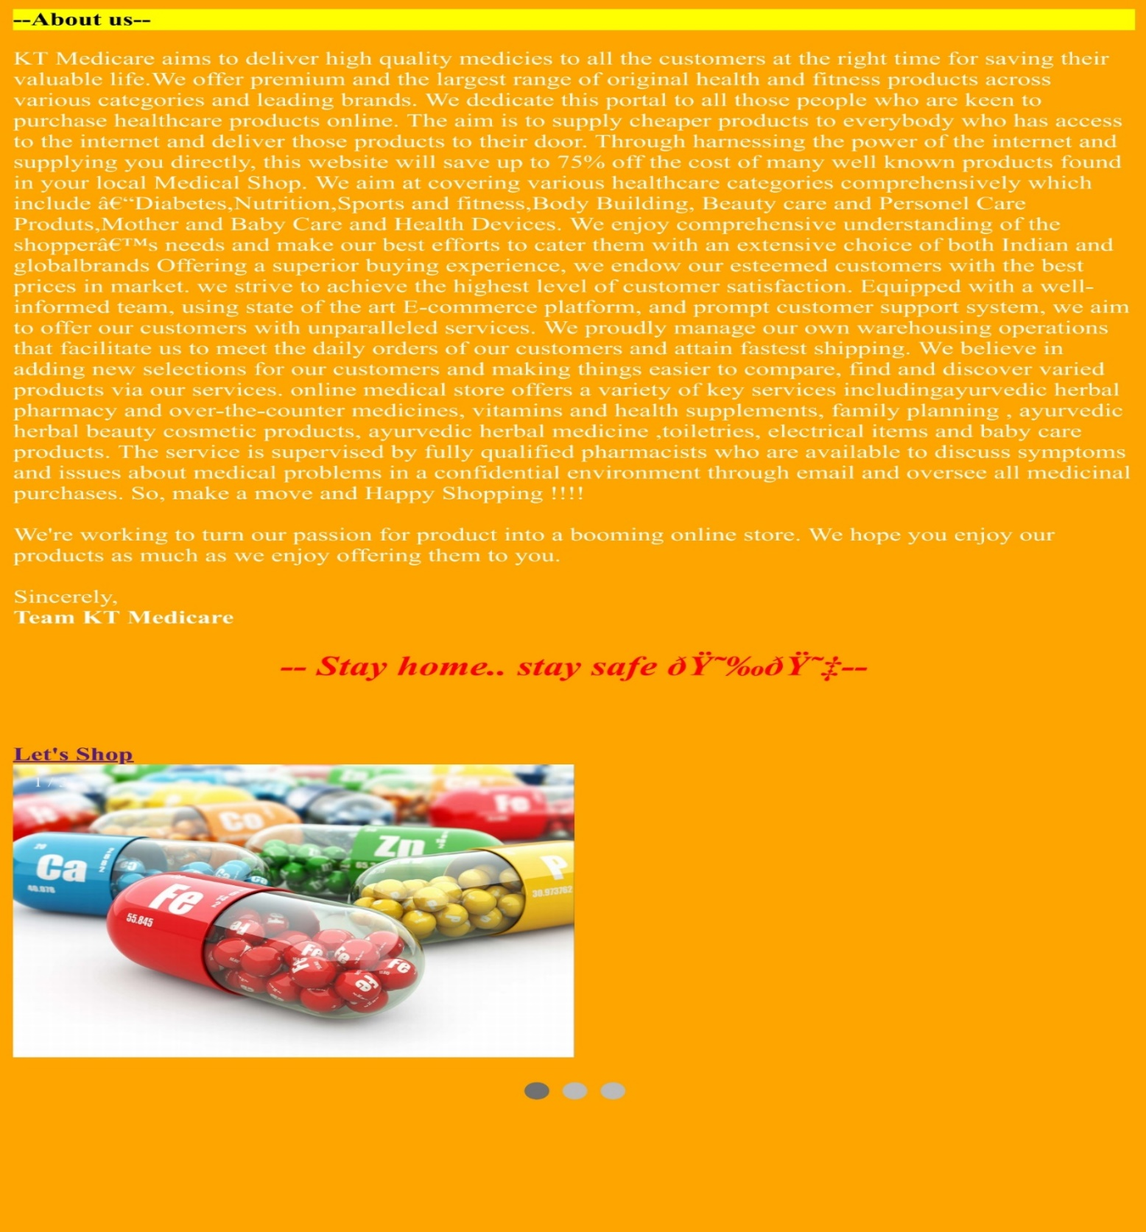

**PRODUCT PAGE**

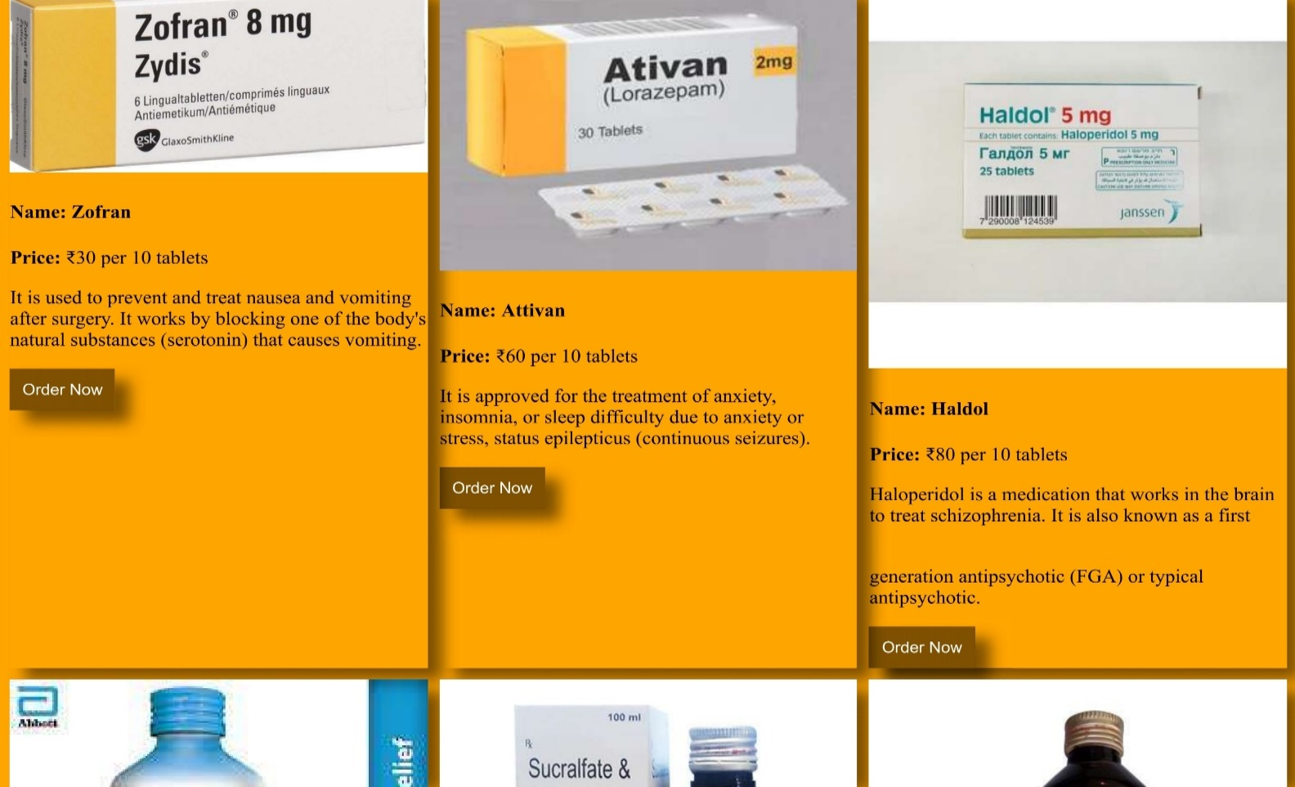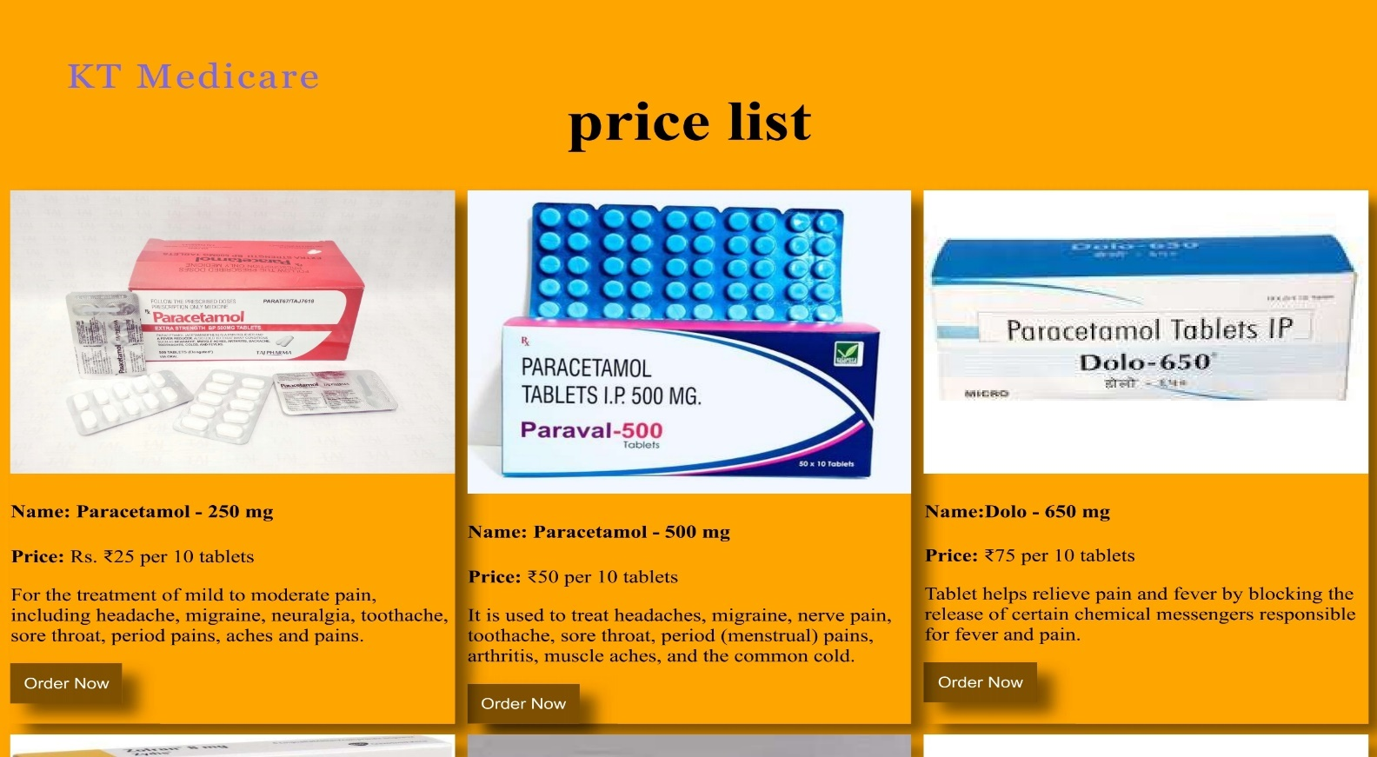

**MEDICINE ORDER PAGE**

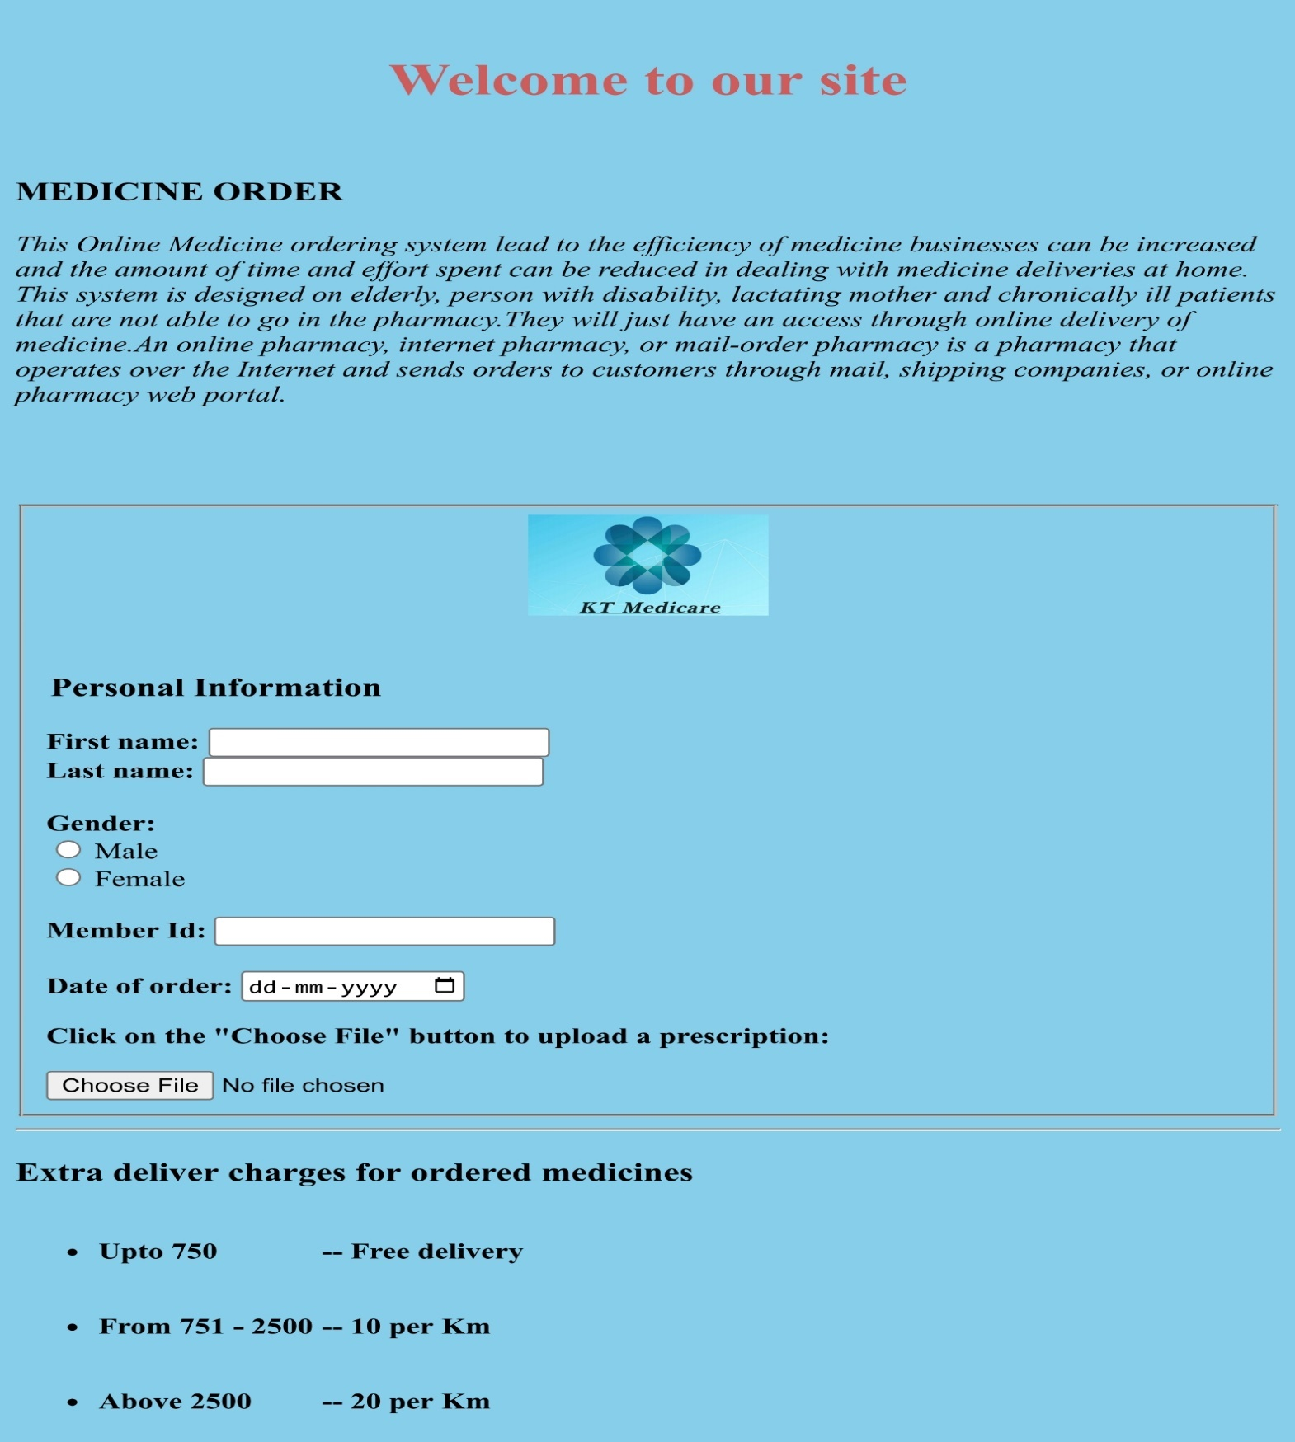

**CONTACT**

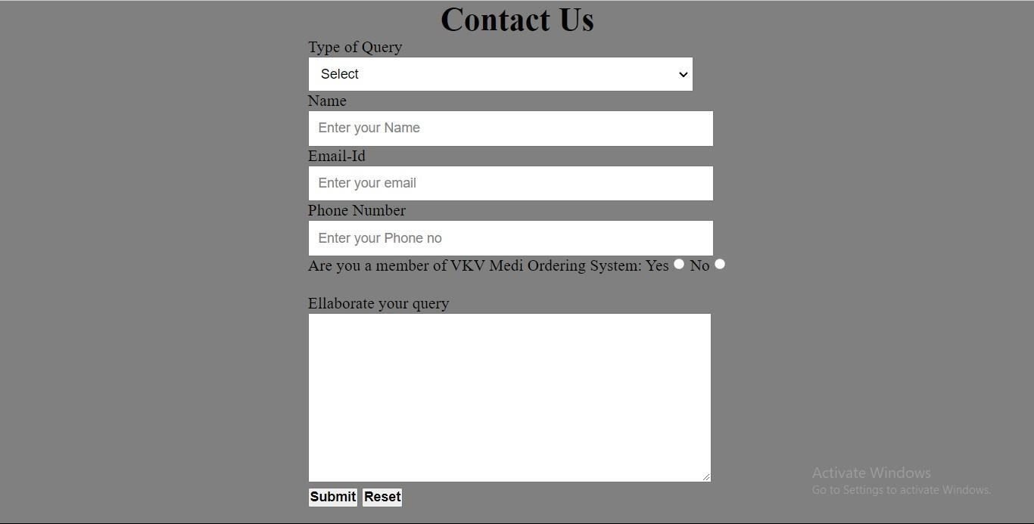

# SYSTEM TESTING

Implementation is the stage of the project when the theoretical design is

turned into a working system. This is the final and important phase in the system life cycle It is actually the process of converting the new system into a operational one.

## Unit Testing

Unit testing comprises the set of tests performed by an individual programmer prior to integration of the unit into a larger system. The module interface is tested to ensure that information properly flows into and out of the program unit. The local data structure is examined to ensure that data stored temporarily maintains its integrity during all steps in an algorithm’s execution. Boundary conditions are tested to ensure that the module operates properly at boundaries established to limit or restrict processing. All independent paths through the control structure are tested. All error- handling paths are tested.

# SYSTEM IMPLEMENTATION

Implementation is the stage of the project when the theoretical design is turned into a working system. This is the final and important phase in the system life cycle It is actually the process of converting the new system into a operational one.

**CONCLUSION AND FUTURE ENHANCEMENTS**

# CONCLUSION

We will hire some delivery people to deliver the medicines. We also need marketing people to make it available to the wider users of the system. As a startup company it is predicted that it will have huge success by cindering the current demand of this system. After launching when we will have huge customer data and reviews we will apply big data analysis and machine learning technique to get more customers and for suitability of the system.

# FUTURE ENHANCEMENTS

This chapter discusses the future scope or the implementation of this system. Our online medicine delivery system will be explored with some future plans door to door. In future more extra features will be added. It will include the android mobile application with many advanced features. We have planned to launch this web- application as a business site which will work as an e-commerce site.

**Bibliography**

**Websites**

* [www.javat.com](http://www.javat.com)
* [www.geeksforgeeks.com](http://www.geeksforgeeks.com)
* [www.Wikipedia.com](http://www.Wikipedia.com)

***YouTube Channels***

* Code with Harry
* Apni Kaksha